Hands On Exercises - Java Constructors and Static Methods

**Setup Instructions:**

1. Create a new Word document- “AssignmentsDay3.docx” .
2. Answer Assignment 01.
3. Create a new Java Project called “JavaFundamentals3”.
4. Create your classes in the specified package.
5. Define your classes as given below for each assignment.

Assignment 01

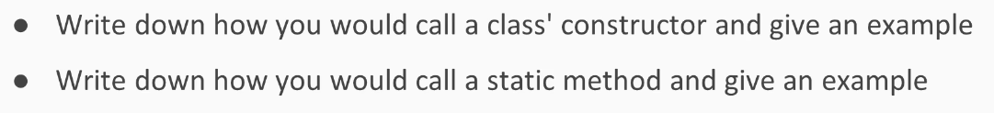

Assignment 02

Write a constructor in the Car class given below that initializes the brand class field with the string “Ford”.

Call the getBrand() method in the main method of the Sample class  and store the value of the brand in a variable, and print the value.

Put the classes in any package of your choosing.

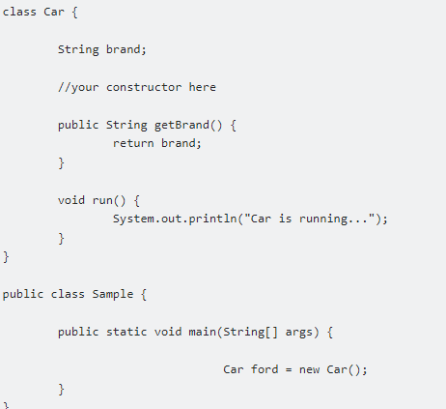

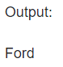

Assignment 03

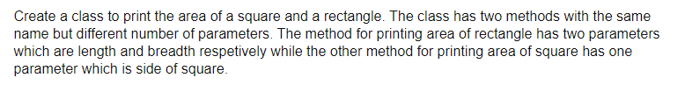

The name of the class is “Area”.

The overloaded method is called printArea(…).

The data type of the method parameters is “int” in both cases.

Create a main method in the same class and invoke the overloaded methods as follows:

1. Call printArea() with two integers.
2. Call printArea() with one integer.

Assignment 04



Create a class to test the Student objects as follows:

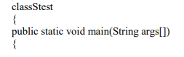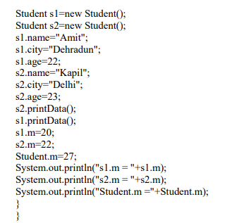

**The next two assignments are all about testing methods including static methods.**

Assignment 05

Create a class to mimic the roll of a dice as follows:

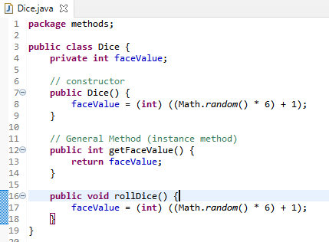

Create a class to test the above as follows:

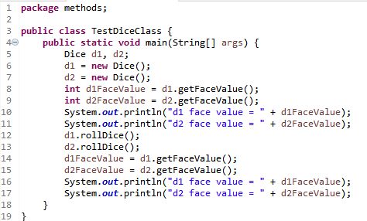

Output

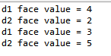

Assignment 06

Create a class to demonstrate the usage of methods including static methods as follows:

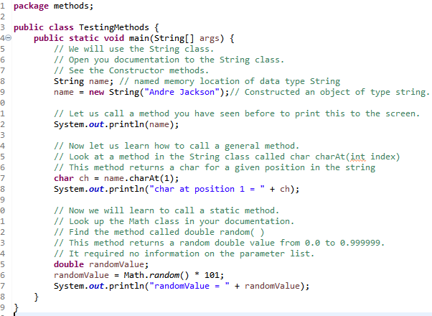

Output



*****************************************************************************************************************